

**Object Oriented Programming Lab**

**Name:** Pratham Kandari

**Sap Id:** 500097663

**Batch:** 7

**Experiment -3**

1. Write a program to accept three digits (i.e., 0 - 9) and print all its possible combinations. (For example if the three digits are 1, 2, 3 than all possible combinations are : 123, 132,213, 231, 312, 321.)

Ans:

import java.util.*;

class Combination

{

public static void main(String[] srgs)

{

Scanner sc=new Scanner(System.in);

System.out.println("enter the three numbers");

int [] arr=new int[3];

for(int i=0;i<3;i++)

{

arr[i]=sc.nextInt();

}

int temp=0;

for(int i=0;i<3;i++)

{

for(int j=i+1;j<3;j++)

{

if(arr[i]>arr[j])

{

temp=arr[i];

arr[j]=arr[i];

arr[i]=arr[j];

}

}

}

System.out.println("All possible combinations are: ");

if(arr[0]!=arr[1] &&arr[1]!=arr[2] && arr[0]!=arr[2])

{

for(int p=0;p<arr.length;p++)

{

for(int q=0;q<arr.length;q++)

{

for(int r=0;r<arr.length;r++)

{

if(p!=q &&q!=r && p!=r)

{

System.out.println(arr[p]*100+arr[q]*10+arr[r]);

}

}

}

}

}

else if(arr[0]==arr[1]&&arr[1]==arr[2])

{

System.out.println("all numbers are same so the only possible combination is\n"+(arr[0]*100+arr[1]*10+arr[2]));

}

else if(arr[0]==arr[1] || arr[1]==arr[2]|| arr[0]==arr[2])

{

for(int p=0;p<arr.length;p++)

{

for(int q=0;q<arr.length;q++)

{

for(int r=0;r<arr.length;r++)

{

if(p!=q &&q!=r )

{

System.out.println(arr[p]*100+arr[q]*10+arr[r]);

}

}

}

}

}

}

}

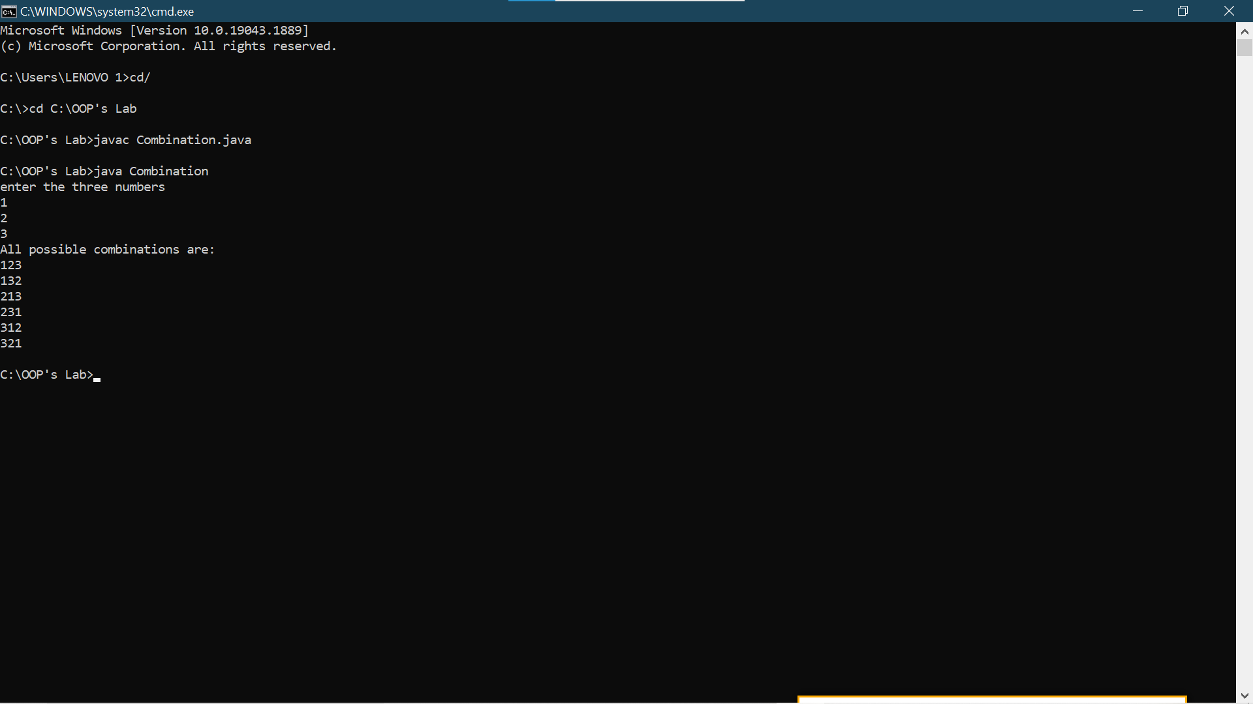

1. Write a Java Program to accept 10 numbers in an array and compute the square of each number. Print the sum of these numbers.

Ans:

import java.util.*;

class ExpThreeTwo

{

int result =0;

public void Square()

{

Scanner sc=new Scanner(System.in);

int i=0;

int a[]=new int[10];

for(i=0;i<10;i++)

{

System.out.println("Enter a no");

a[i]=sc.nextInt();

}

for(i=0;i<10;i++)

{

result=result+a[i]*a[i];

}

System.out.println("The result is "+result);

}

public static void main(String args[])

{

ExpThreeTwo obj=new ExpThreeTwo();

obj.Square();

}

}

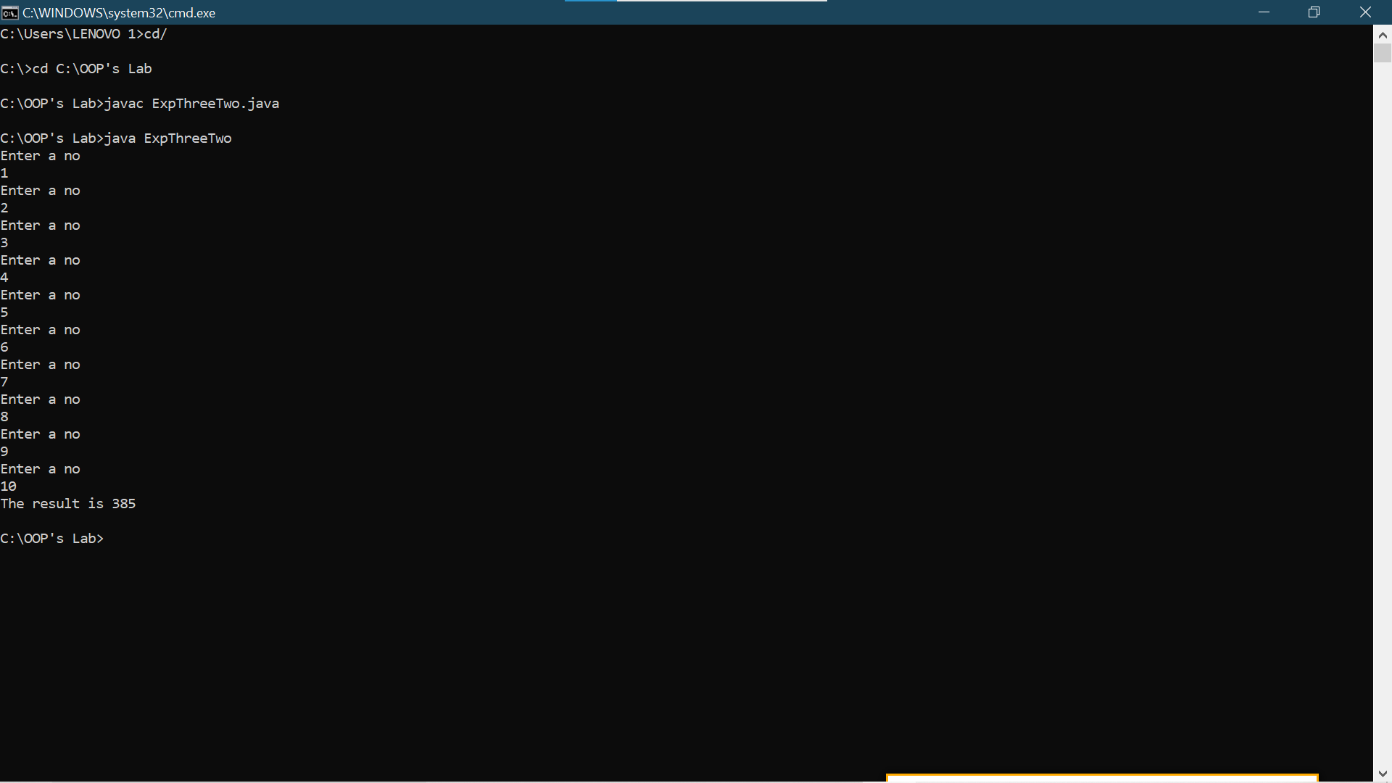

1. Write a program to input a number of a month (1 - 12) and print its equivalent name ofthe month. ( e.g 1 to Jan, 2 to Feb. 12 to Dec).

Ans:

import java.util.*;

class ExpThreeThree

{

public static void main(String args[])

{

Scanner sc=new Scanner(System.in);

System.out.println("Enter 1 for January");

System.out.println("Enter 2 for February");

System.out.println("Enter 3 for March");

System.out.println("Enter 4 for April");

System.out.println("Enter 5 for May");

System.out.println("Enter 6 for June");

System.out.println("Enter 7 for July");

System.out.println("Enter 8 for August");

System.out.println("Enter 9 for September");

System.out.println("Enter 10 for October");

System.out.println("Enter 11 for November");

System.out.println("Enter 12 for December");

System.out.println("Enter your choice");

int choice=sc.nextInt();

switch(choice)

{

case 1:

System.out.println("January");

break;

case 2:

System.out.println("February");

break;

case 3:

System.out.println("March");

break;

case 4:

System.out.println("April");

break;

case 5:

System.out.println("May");

break;

case 6:

System.out.println("June");

break;

case 7:

System.out.println("July");

break;

case 8:

System.out.println("August");

break;

case 9:

System.out.println("September");

break;

case 10:

System.out.println("October");

break;

case 11:

System.out.println("November");

break;

case 12:

System.out.println("December");

break;

default:

System.out.println("INVALID CHOICE");

}

}

}

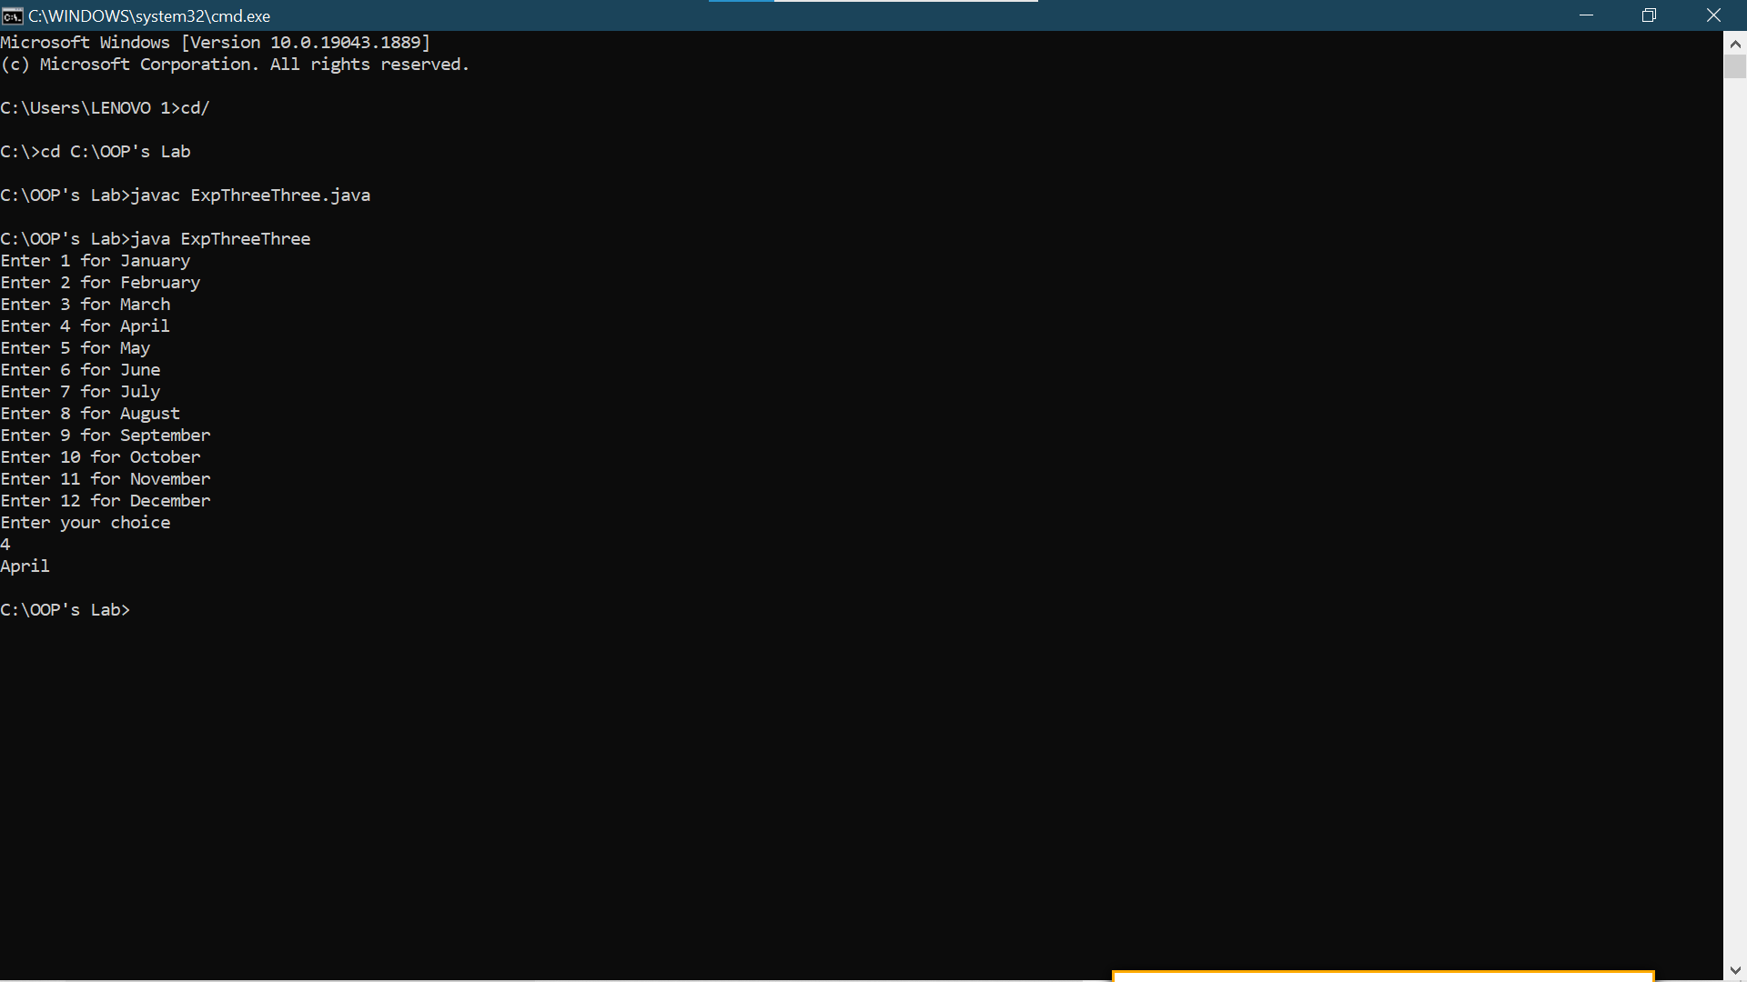

1. Write a program to find the sum of all integers greater than 40 and less than 250 that are divisible by 5.

Ans:

class ExpThreeFive

{

int func()

{

int sum=0,i=0;

for(i=41;i<250;i++)

{

if(i%5==0)

{

sum=sum+i;

}

}

return sum;

}

public static void main(String args[])

{

ExpThreeFive ob = new ExpThreeFive();

int result = ob.func();

System.out.println("The sum is "+result);

}

}

